**Ankara University**

A Project Report on

Traffic Light Controller

ASSOC. DR. Gazi Erkan BOSTANCI

By:

Mohammed Natour, № 20290168

&

Ibrahim Najjar, № 20290167

**Faculty of Engineering**

**Department of Computer Engineering**

**Microprocessors and Embedded Systems - 3525**

Briefing:

We will be designing a 2-way traffic light controller using VHDL and Mentor Graphics’ ModelSim and implementing a finite state machine; the state of the traffic lights will change according to a preset timer; we will have traffic lights on the North-South and East-West streets as demonstrated below.

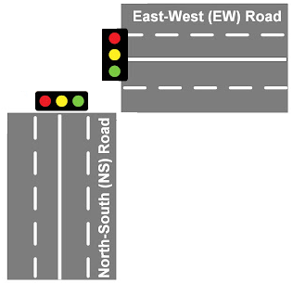

the sequence of operations for our system:

1. In the beginning all lights are Red for 5 seconds
2. The NS lights Red and Yellow together for 5 seconds (Ready state), the EW light remains Red
3. The NS Red and Yellow is turned off and Green remains on for 1 minute, the EW light remains Red
4. The NS Yellow lights for 5 seconds and Green turns off, the EW light remains Red
5. After 5 seconds, the NS Yellow turns off
6. We go back to step 1 and swap EW and NS

What we learned

After successfully designing and implementing a traffic light controller. We have gained experience of how to employ a high-level language like VHDL to implement system instead of dealing with gate-level implementation.

using high-level synthesizers can help speed up the design process and reduce prototyping costs; Moreover, we have learned how to deduce data from and analyze waveforms. Lastly, we learned how to use procedures and modules in ModelSim to eliminate redundant code as much as possible and increase readability, we especially noted that parameter-passing can be very powerful functionality if used correctly.

There’s room for improvement

1. Install sensors to detect the presence of vehicles and change the traffic light state accordingly such that traffic doesn’t have to wait for an empty street. Additionally, we can dynamically change the lighting duration for each street according to traffic thus reducing traffic.
2. After hours, there is less traffic than usual and essentially no need for traffic lights; we can have the traffic lights flash red and yellow signaling the driver to proceed with caution – no need to stop.
3. Install sensors which detect the cars going the speed limit and extend the yellow light duration in order to avoid collisions and sudden braking.